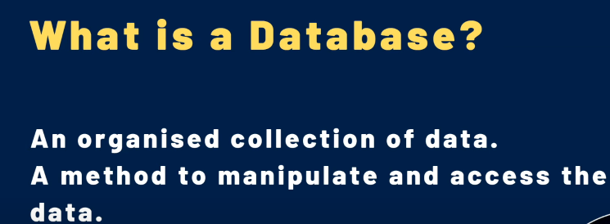

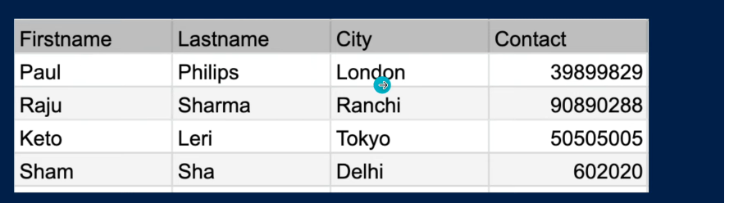

**DBMS:-**

Database Management Systems (DBMS) are software systems used to store, retrieve, and run queries on data.

RDBMS:-

A relational database management system (RDBMS) is a program used to create, update, and manage relational databases.

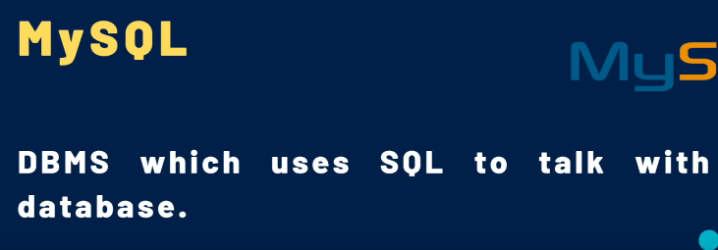

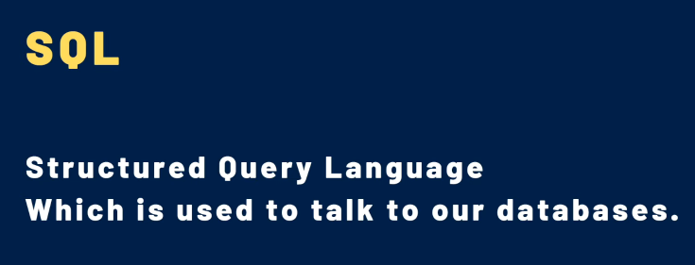



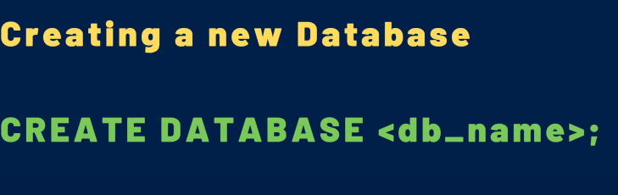

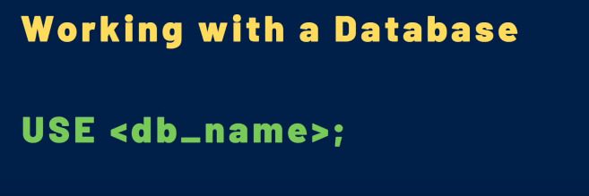



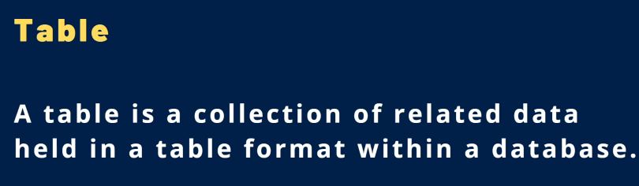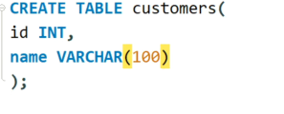



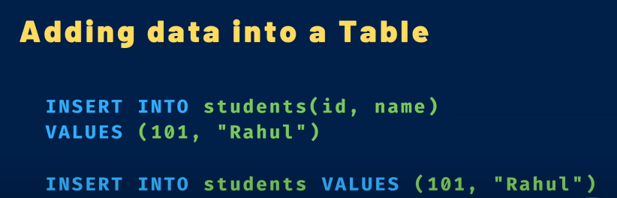

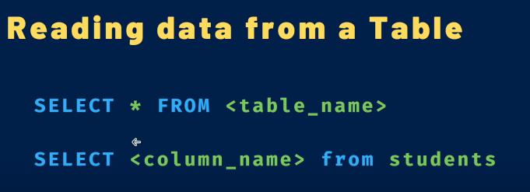



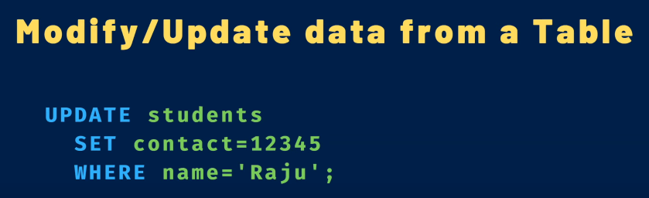

**Not Null:-**

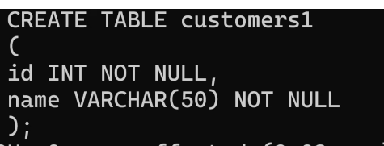

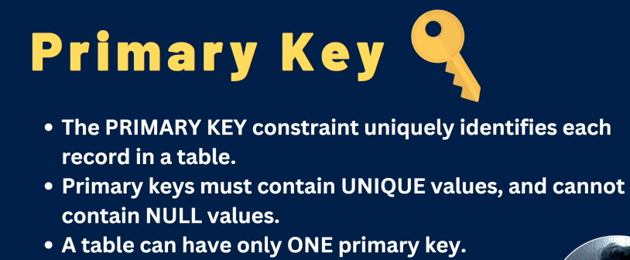

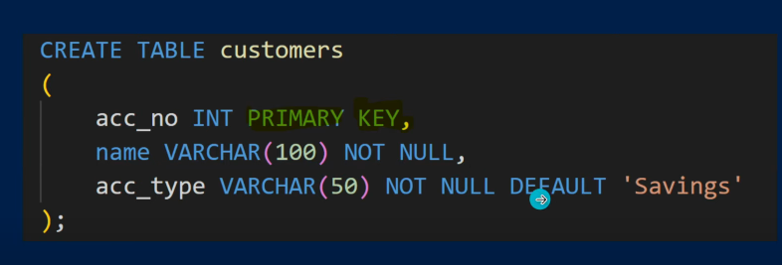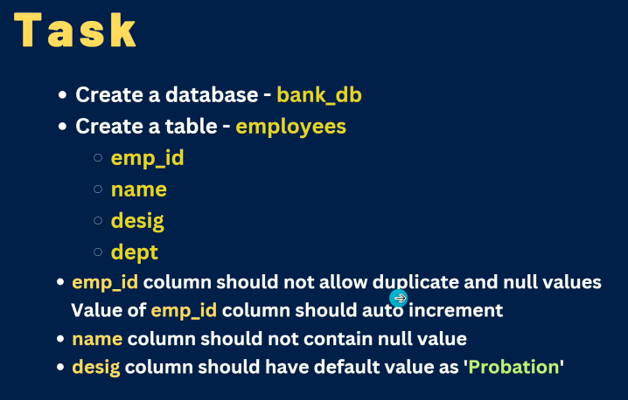

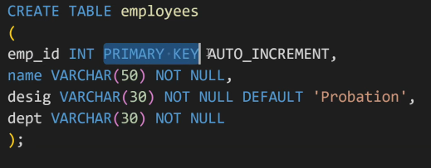



**1.**









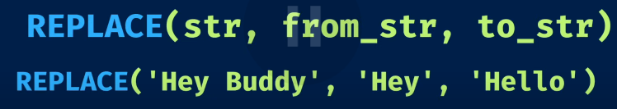



































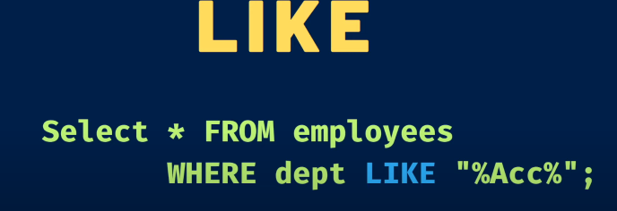



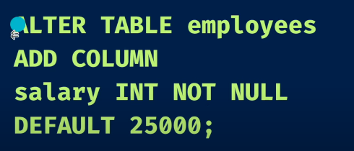





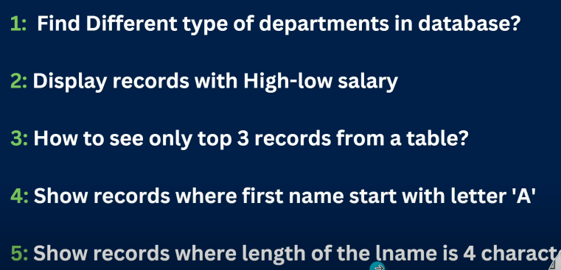

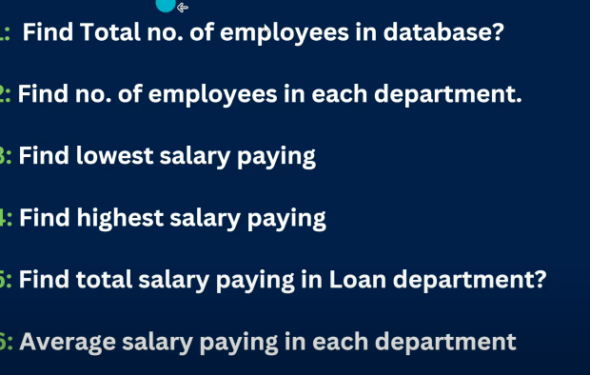

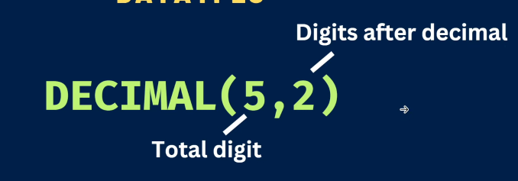

**\**

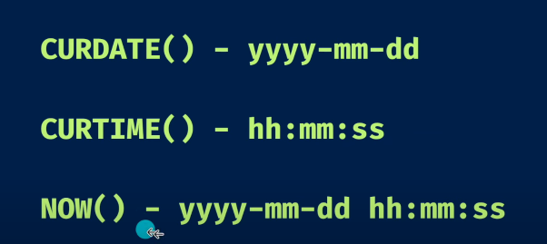



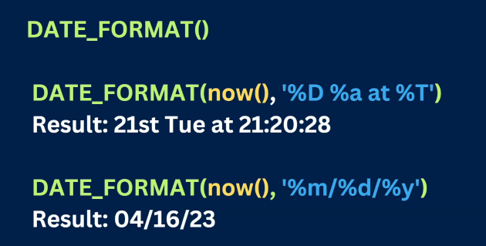











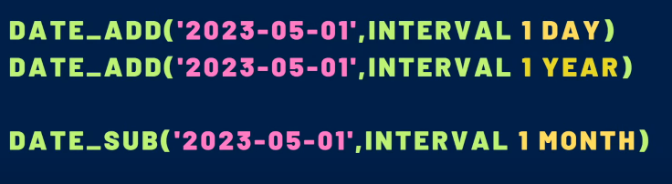



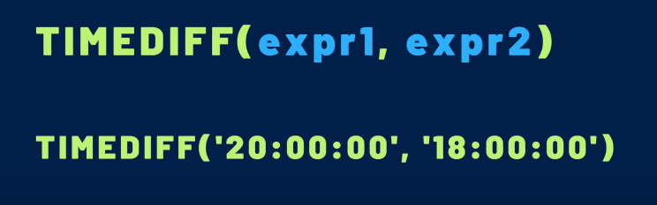



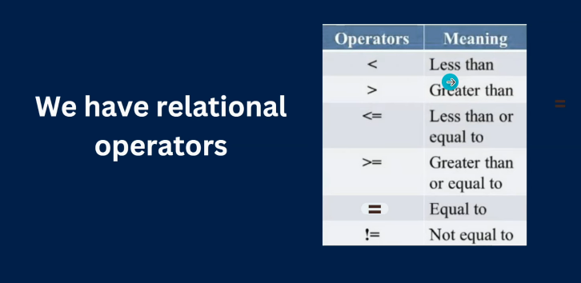





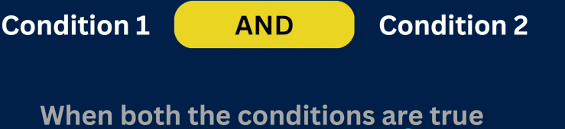

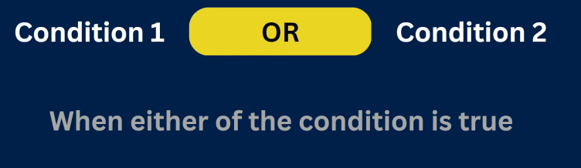











**\**

**SUB QUERY:-**

**QUERY INSIDE ANOTHER QUERY IS CALLED SUB QUERY.**

**CREATE TABLE CUSTOMERS ( ID INT NOT NULL,NAME VARCHAR(20) NOT NULL,AGE INT NOT NULL, ADDRESS CHAR (25),SALARY DECIMAL (18, 2),PRIMARY KEY (ID));**

**INSERT INTO CUSTOMERS VALUES(1, 'Ramesh', 32, 'Ahmedabad', 2000.00),(2, 'Khilan', 25, 'Delhi', 1500.00),(3, 'Kaushik', 23, 'Kota', 2000.00),(4, 'Chaitali', 25, 'Mumbai', 6500.00),(5, 'Hardik', 27, 'Bhopal', 8500.00),(6, 'Komal', 22, 'Hyderabad', 4500.00),(7, 'Muffy', 24, 'Indore', 10000.00);**

**select * from CUSTOMERS where ID IN (select ID from CUSTOMERS where SALARY<4500);**